Consultant Information Form

Date of Joining: (05/03/2022) :

Designation at Aloha Technology: consultant

Personal Details:

Name: _ Hrishikesh ______________Pravin_______________Shankhapal________
First Name Middle Name Last Name

Date of Birth: ___17/11/1998____ Marital Status: __UnMarried_____________

Present Address: _589, Janta Raja Chawk, at post Gandhali, tal. Amalner, dist. Jalgaon

, Maharashtra, 425420._________________ Res. Tel: __________________

Permanent Address589, Janta Raja Chawk, at post Gandhali, tal. Amalner, dist. Jalgaon

, Maharashtra, 425420._________________ Res. Tel: _________________

MobileNo:_____ 8007109264___________ E-mail ID ____shankhpalh@gmail.com______
PAN No-: _MPCPS3944C______

Driving License No: - _____NA______

Voter ID :- ______NA_______________

Addhar No :- 465495669269________

Any relatives in Aloha Technology: __NA____ If yes, give details _______________________

Name Position Relationship
_______________________________________________________________________________

Family Background:

 | Name | Age | Educational Qualification | Occupation
 |  |  |  | Government | Others
Father | Pravin shankhapal | 50 | 10th |  | farmer
Mother | Mangala shankhapal | 50 | 12th |  | House wife
Spouse | NA
Sister (s) | Devashree shankhapal | 27 | BE IT |  | s/w developer
 | Mayuri Shankhapal | 25 | BE Mechanical |  | designer
Brother (s) | Girish shankhapal | 21 | BE E&TC |  | student
Child

Education: BE Computer engineering 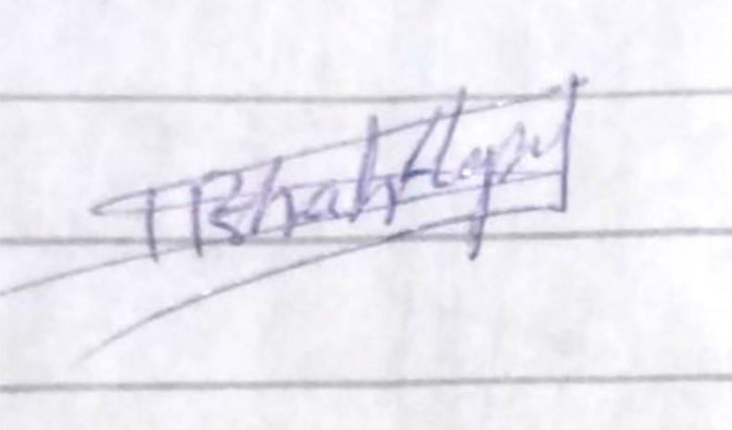

List in order starting with highest degree / diploma

School / College / University | Period |  | Degree/  Diploma | Specialization | % | Class/Div | Scholarship/ Prize
 | From | To
G. S. Highschool | 2013 | 14 | SSC |  | 82.20 | distinction
Pratap college, amalner | 2015 | 16 | HSC | Science | 64.92 | First class
AVCOE, sangamner | 2016 | 20 | BE | Computer Engineering | 65.27 | First class

Computer Experience:

Computer Systems |  | O.S. | Programming Languages | Application(s)  Software Package(s)
Manufacturer | Model
 |  | Xp | Javascript | Reactjs
 |  | linux | HTML5 | Angular 9/10
 |  | W10 | CSS3 | Mongoose
 |  |  | C | MySQl
 |  |  | C++ | Node js
 |  |  |  | Express js
 |  |  |  | Nest Js

Research Projects/Summer Training:

Name of the Institution/Organization | Details

Research Papers (Published):

Journal | Publication year | Paper Title
Write-ups on Technical Issues
Lectures on different Topics

Languages (Indian & Foreign):

Speak | English | Hindi | Marathi
Read | English | Hindi | Marathi
Write | English | Hindi | Marathi

Employment History:

Start with your present job and work backwards. Count for time whenever unemployed.

Sr,  No. | Name, Address and Phone No. of  Employer | Period |  | Designation | Nature of duties | Last Salary  Drawn
 |  | From | To
1 | Cognizant Technology solutions,  pune | Feb 2021 | present | Programmer Analyst | Full Stack developer | 28 feb 2022
2.

Countries traveled abroad: _____NA____________________________________________

Passport No. _U7200085____ Place of Issue ___MUMBAI______Nationality _INDIAN______

Date. of Expiry __09/12/2030____

If not, have you applied for a Passport? _________ Place and Date of Application ________

Have you been refused Visa any time? If yes, give details _____NA______________________

Country | Date of Application | Type of Visa | Reason of refusal
1.
2.
3.

Medical Information:

Any Physical Problem ( If yes give details ): ______NA________________________________________________________________________________________________________________________________________________________________________________________________________________________________________________

Allergic to any medicine etc _____NA______________________________________________________

Blood Group :-____0+___________________________________________________________________

Extracurricular Activities:

_________________________________________________________________________

Membership in Professional Societies ___________________________________________

Membership in Social / Culture Clubs ____________________________________________

Hobbies ______________________________________________________________

References:
Name
Designation
Address
Tel No.

Career Objectives:

State your career objectives for the next three years (Please be specific) ________________
I want to be Entrepeneur in next 3-4 years

General:

Have your applied to us earlier? NO

If yes, give details:

Declaration:

I certify that the information furnished above is factually correct and subject to verification by Aloha
I also certify that I am at present I sound mental and physical condition to undertake employment with Aloha.
I accept that an appointment given to me on this basis can be revoked, if any information has been misstated or unstated.

Signature of Applicant _______ Date: __04/03/2022__

